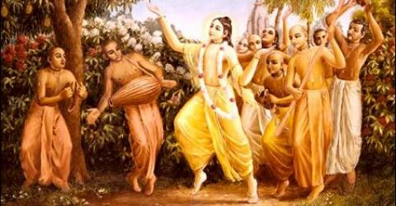
SOLDIERS OF GODHEAD
JUNE 2010 EDITION
For receiving free monthly subscription, write into soldiersofgodhead@yahoo.com

Contents

- Maya-the illusionary energy. Pg.3

- The disease called ego. Pg.7

- Ekadashi Pg.10

- The path to perfection. Pg.13

- The purpose of human life. Pg.17

MAYA- THE ILLUSIONARY ENERGY

Maya means that which is not reality. The jive atma is under this illusionary energy of the Lord and under its illusion considers himself as the source of creation, the enjoyer and denies the existence of God. This form of foolish thinking arises out of Maya. Maya is also known as the external or inferior energy of the Lord. The Lord has three energies as confirmed in the Bhagavad Gita and Srimad Bhagavatam- Internal or supreme energy, external or inferior energy and marginal or superior energy. The internal energy of the Lord, which is also known as the supreme energy or shakti,, is called Hara who is actually Maa Durga who is the para shakti of the Lord. While chanting HARE KRISHNA HARE KRISHNA KRISHNA KRISHNA HARE HARE/ HARE RAMA HARE RAMA RAMA RAMA HARE HARE, we are in reality, transcendentally appealing to HARA or Maa Durga to free us from material contamination and help us develop pure love for Lord Krishna. The external or inferior energy of the Lord is Maya (illusionary power) which is the source of the material cosmic manifestation. This energy governs the mind of the jiva atma and makes it think that he is supreme and not the Lord. We are actually parts and parcels of the Supreme Lord, and are his children and eternal servitors. This is our true constitutional position. Realization of this constitutional position is true self realization. The marginal energy of the Lord is the jiva atma. We are also known as the superior energy because we are superior to the material energy (maya) as we have consciousness and material nature dose not and are the parts and parcels of Lord Sri Krishna. This means that we have the capacity to overcome our illusion and ego and understand and love Lord Krishna which is true perfection. In the third chapter of the Bhagavad Gita, Lord Krishna tells Arjun to gain control over his senses and that will help him transcend the modes of material nature. In the hierarchy of the material body, first come the senses, then the mind, then intelligence and above intelligence the spirit soul or the jiva atma. The understanding that we are not this body but the spirit soul (jiva atma) is the first step in self realization. When one comes to this understanding then one is able to control his senses by controlling the mind by restricting it from thinking of material things and this is achieved through intelligence which in turn is received from a realized soul- the bonafied spiritual master. In this way it is evident that without the assistance of a spiritual master, it is difficult or next to impossible to gain control over the senses. Maya can also be understood as a test taken by the supreme lord to ensure that only his true devotees receive transcendental knowledge which helps them in crossing over this material ocean of suffering and entering into the lord’s abode-Goloka Vrindavan. Those who waste their lives in wandering for material pleasures and don’t inquire about their true self and their constitutional position in relation to the supreme lord and their purpose in life, fail this test and have to take birth after birth till they come to the conclusion that Krishna is the Supreme Personality of Godhead. When a jiva atma arrives at this conclusion, he passes the test of maya and develops pure love for Krishna and enters his spiritual kingdom.
Hare Krishna!

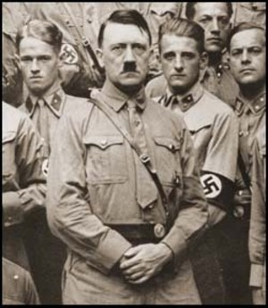
Adolf Hitler, the best example for personification of ego and its downfall.

THE DISEASE CALLED EGO

Ego, which is a combination of ahamta (“I”ness) and mamata (myness) is a disease common in jiva atmas in this material world. There are only a few souls who are free from the clutches of this disease. Even demigods and Ishvars like Lord Brahma and Shiva are not free from this disease. The reason it is a disease is because it does no good to anyone, it is not pleasing to anyone and is the reason for the downfall of the diseased persons, but above all, it is a stumbling block in the process of devotional service. Ego is the cause of our bondage in this material world. Owing to our ego, we consider the land of our birth to be the best and disrespect or encroach the lands of other people, we consider ourselves to be the best owing to some bread and butter knowledge acquired in modern day educational institutions, or consider our religion or philosophy to be the best etc. These are different areas in life where the stains of ego can be found. Ego comes in different forms, like self confidence, pride, self esteem, excessive self respect, rigidness, stubbornness, greed, selfishness, self-consciousness, being self centered, being ambitious for material titles or pleasures, anger etc. When one identifies these qualities in one self, he should understand that he is egoistical.
What has been explained above is the disease and its symptoms, but what about the cure? The answer to this and all other problems of this material world is Krishna Consciousness. When one replaces that “I” in the mind with “Krishna”, he automatically begins to render service at the lotus feet of Krishna. People in general work, thinking “I am working for myself and family” or “I should serve my country” or “I am working for humanity” etc. But these are egoistical statements where one considers himself to be the doer and cause of the action being performed and tries to imperfectly satisfy himself through the results of such actions. When one works for his own satisfaction, it is called selfishness. But when one works for his family, friends, community, society, nation, etc. one is working, thinking that he is serving “his” family, “his” friends, “his” community etc. This is known as ‘expanded selfishness’. Instead, when one thinks, “I am serving Lord Krishna, and He is the cause and enjoyer of everything and I am His eternal child and servitor.” This form of thinking releases one from the bondage of this material world as we are not to enjoy or suffer the results of our actions.
When we say “service to Lord Krishna” it does not necessarily mean temple service. In whichever profession one maybe engaged, he/she must not bother about the fruits of the actions he/she is performing and should perform his/her duty with dedication, honesty and faith in Lord Krishna. One must remember at all times that Krishna is the doer and enjoyer of everything. We are only his servitors. One must give credit to God for all achievements and should take responsibility for all failures in life and not accuse God, since we are bearing the fruits of our past actions which were performed for our sense gratification. In this manner, when we begin to submit the fruits of our activities or karmafals in the lotus feet of Lord Krishna, we are not entitled to bear the results of our activities and in this way, even by being engaged in normal routine activities of day to day life, we experience liberation, peace, satisfaction, happiness and true pleasure. When one is cured of this disease, he/she shall realize his/her constitutional position and become a fit candidate to go back home, back to Godhead.
Hare Krishna!

EKADASHI

Ekadashi is the eleventh day after the new moon and full moon. This is a very auspicious day for vaishnavs (followers of lord Krishna). It occurs twice in a month and vaishnavas observe fast from sunrise on the day of Ekadashi to till the following day’s sunrise. During this period, one can have water, milk and fruits but must avoid eating them in excess. One must not eat grains, pulses, vegetables or beans or non-veg or fast foods on Ekadashi.
Whatever one eats during Ekadashi, he must do so only after offering it to Lord Krishna as bhoog and then eat the Prasadam or sanctified food. One should wake up before sunrise, take bath and read the Bhagavad Gita and chant Hare Krishna Mahamantra on the japa mala or chanting beads for atleast 108 times. Among the Ekadashis, the Vaikunta Ekadashi which comes in the month of oct-nov is most auspicious. On this day it is believed that the supreme lord opens the gates of Vaikunta (the spiritual sky and abode of lord Narayana) and those who fast on this day (even without water from sunrise to sunrise) are sure to receive moksha or liberation. This year, the Vaikunta Ekadashi is coming on December 17th, as per the Hindu calendar.
The purpose of this fast is to develop self control over the senses and develop devotion. When one disengages his senses from materialism and engages them in the service of Lord Krishna, he is said to be a sadhu or a Krishna Conscious man. For knowing the exact date of Ekadashi and other vaishnava festivals, one must consult the Hindu calendar or the vaishnava calendars available on the websites of ISKCON.
Hare Krishna!

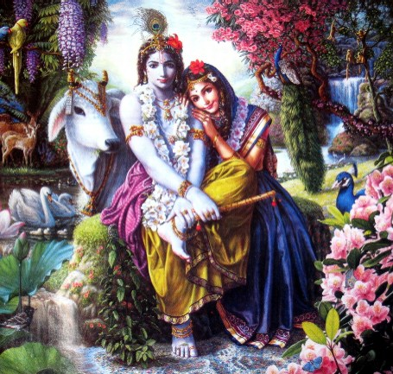
SRI SRI RADHA- KRISHNA

THE PATH TO PERFECTION

There are many so called perfectionists walking on the Earth today. But they are in pursuit of perfection only in material affairs and not in serving the Supreme Personality of Godhead, Lord Sri Krishna. In spite of claiming themselves to be perfect, when they commit a mistake, they say that no one is perfect! This is the hypocrisy of the material world. Lord Sri Krishna is called as purushottama (perfect) since he is transcendental to the three modes of material nature and the illusion of maya as He is the creator of this maya. Thus, the illusionist cannot be illusioned.
We human beings on the other hand are under the influence of Maya and under the three modes of material nature namely; ignorance, passion and goodness. Our activities such as thinking, talking, working, eating, sleeping, entertainment etc are all determined by our respective modes of material nature. For eg. A devotee of God wakes up before sunrise, takes bath, does puja, reads sacred scriptures, eats only prasadam and engages in discourses concerning self realization and is of kind and loving nature. But a non- devotee or one in the mode of ignorance, eats non-veg, fast foods, drinks, smokes, enjoys illicit sex life and refuses to accept the authority of God. Thus, according to the modes we acquire on the basis of our actions in past lives, the extant of our illusion is determined. In this way it can be concluded, that the present life is the preparation or background for the next life. It is very easy for a devotee to understand God but the same cannot be said for a non- devotee. Hence, those who want to understand God through mental and philosophical speculation spend all their lives breaking their heads behind the word jugglery of the mayavadi or atheistic philosophies. But a devotee of God does not waste his time in such activities. Instead, he engages in rendering personal service to God by chanting His holy names-HARE KRISHNA HARE KRISHNA KRISHNA KRISHNA HARE HARE/HARE RAMA HARE RAMA RAMA RAMA HARE HARE. By chanting this Hare Krishna Mahamantra, one develops pure love for Krishna and becomes his intimate friend and devotee.

We are often told to fear God. But God is not someone to be afraid of. Are we afraid of our own parents who are the source of our being? No. God is to be loved and united with. Only non-devotees and people of demonic tendencies fear the Lord and his rage. This is the path to the supreme perfection. When one develops pure love for Krishna, free from material sense gratificationary desires and desires nothing but the association of Lord Krishna, he is said to be truly perfect. Such a devotee of Lord Krishna is very rare. There are few examples in history about such devotees of the lord such as Mirabai, saint Tukaram, Maharaja Ambrisha, Sri Yamunacharya, Prahalada Maharaj, Sukhadeva Goswami, Manu, Vivasana, Lord Kapila, Sudama etc. When one faithfully follows in the path of such devotees of the Lord, one attains the supreme perfection-pure love for Krishna.
Hare Krishna!

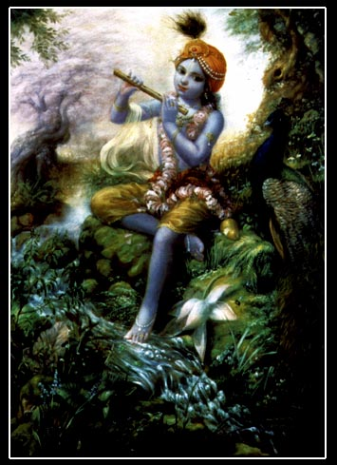

KRISHNA, THE SUPREME PERSONALITY OF GODHEAD

THE PURPOSE OF HUMAN BIRTH

According to the Padma Purana, there are 8.4million spicies of life forms in the universe. The jive atma, according to its karma and desires for sense gratification is given a suitable body in every life. When one desires simply sense enjoyment and laments for it, he is given the body of a dog. When he is desirous of eating inappropriate food items, he is given the body of a hog. In this way, after millions of births in various species of life forms, when one gets the body of a human being, he is very fortunate.
In other forms of life, one is engaged in activities of animal propensities such as eating, sleeping, mating and defending. In these life forms there is no intelligence and no room for self realization or inquiry about the self and the constitutional position. Whereas, in the human form there is intelligence and thus there is room for inquiry. Hence, this human form is a loop hole by which a jive atma can take the initiative of understanding himself and his constitutional position in relation to the supreme Lord and escape from the clutches of maya and samsara (the cycle of birth and death). But when one misuses this human form of life in simply engaging in sense gratification and directing his intelligence in the wrong direction, one is not fulfilling the purpose of the human birth and is living the life of a pashu, animal. If one continues to eat non-veg food, fast foods, eggs, alcohol, tobacco, drugs etc and engages in illicit sex and other immoral activities, he degrades his life and is thrown back into the body of an animal after being punished in hell for all wrong doings, according to Garuda Purana.
In the Bhagavad Gita it is mentioned, that when one desires sense gratification it leads to anger if the desire is not satisfied. From anger comes lobha (greed) and from greed comes moha ( myness or attachment) and from attachment, greed and anger, chaitanya (intelligence) is destroyed. And the one, whose intelligence is destroyed, is an animal.
Therefore, rather than leading a sinful life of an animal, being in the human form we should be grateful to the lord and with complete devotion, dedication and sincerity we must surrender at the lotus feet of Lord Krishna and engage in his loving devotional service. This helps the jive atma transcend the modes of material nature and go back home, back to Godhead.

Hare Krishna!

Dedicated in the loving devotional service of Lord Sri Krishna and Srila Prabhupada.

Written, edited, published and distributed by,
Govardhanagirivaradhari Das (Vinay. D. Chakraborty)

“I am grateful to all devotees from whom I have received favorable reviews and encouragement for my endeavor. It is an honor for me to spread the message of Lord Krishna and walk on the path shown to us by our spiritual master-His Devine Grace A.C Bhaktivedanta Swami Prabhupada. I humbly submit the credit of the knowledge contained in this magazine at the lotus feet of Lord Krishna and Srila Prabhupada. Hare Krishna”- Govardhangirivaradhari Das

For subscription to free monthly editions, comments and suggestions write into,
soldiersofgodhead@yahoo.com or contact vinay.chakraborty@yahoo.com

